TASK (PART II):

*Identify 3 most critical user flows, write your insights and send the description.*

1st User flow:

**Create a webpage**

1. User opens <https://zyro.com/trial> page in browser
2. User logs in to Zyro:
   1. New User clicks “**Join Zyro**” button in the upper right corner of the website -> registers with email address, or with Google or Facebook account
   2. Existing User clicks “**Sign in**” button in the upper right corner of the website -> enters email address and password, or continues with Google or Facebook account
3. User initiates a new webpage creation:
   1. New User clicks “**Get started**” button in the center of the website
   2. Existing User clicks “**Create new webpage**” button in the upper right corner of the website
4. User picks a template from template library
5. User clicks “**Start building**” button which appears when user hovers mouse over the template
6. User customizes website template (adds images, text, and other website elements with Zyro’s intuitive website builder); User also can harness AI tools located in the right sidebar
7. User initiates the publication of a webpage by clicking “**Publish website**” button in the upper right corner of the website
8. User chooses a domain by entering a domain name in the label and clicks “**Continue**” button in the lower right corner of the modal
9. New webpage is created. User is informed that website is published and online
10. User clicks “**View your site**” button located on the right side of the domain to open created webpage in a new browser tab

This user flow is shown in the diagram (see “Diagram 1” below).

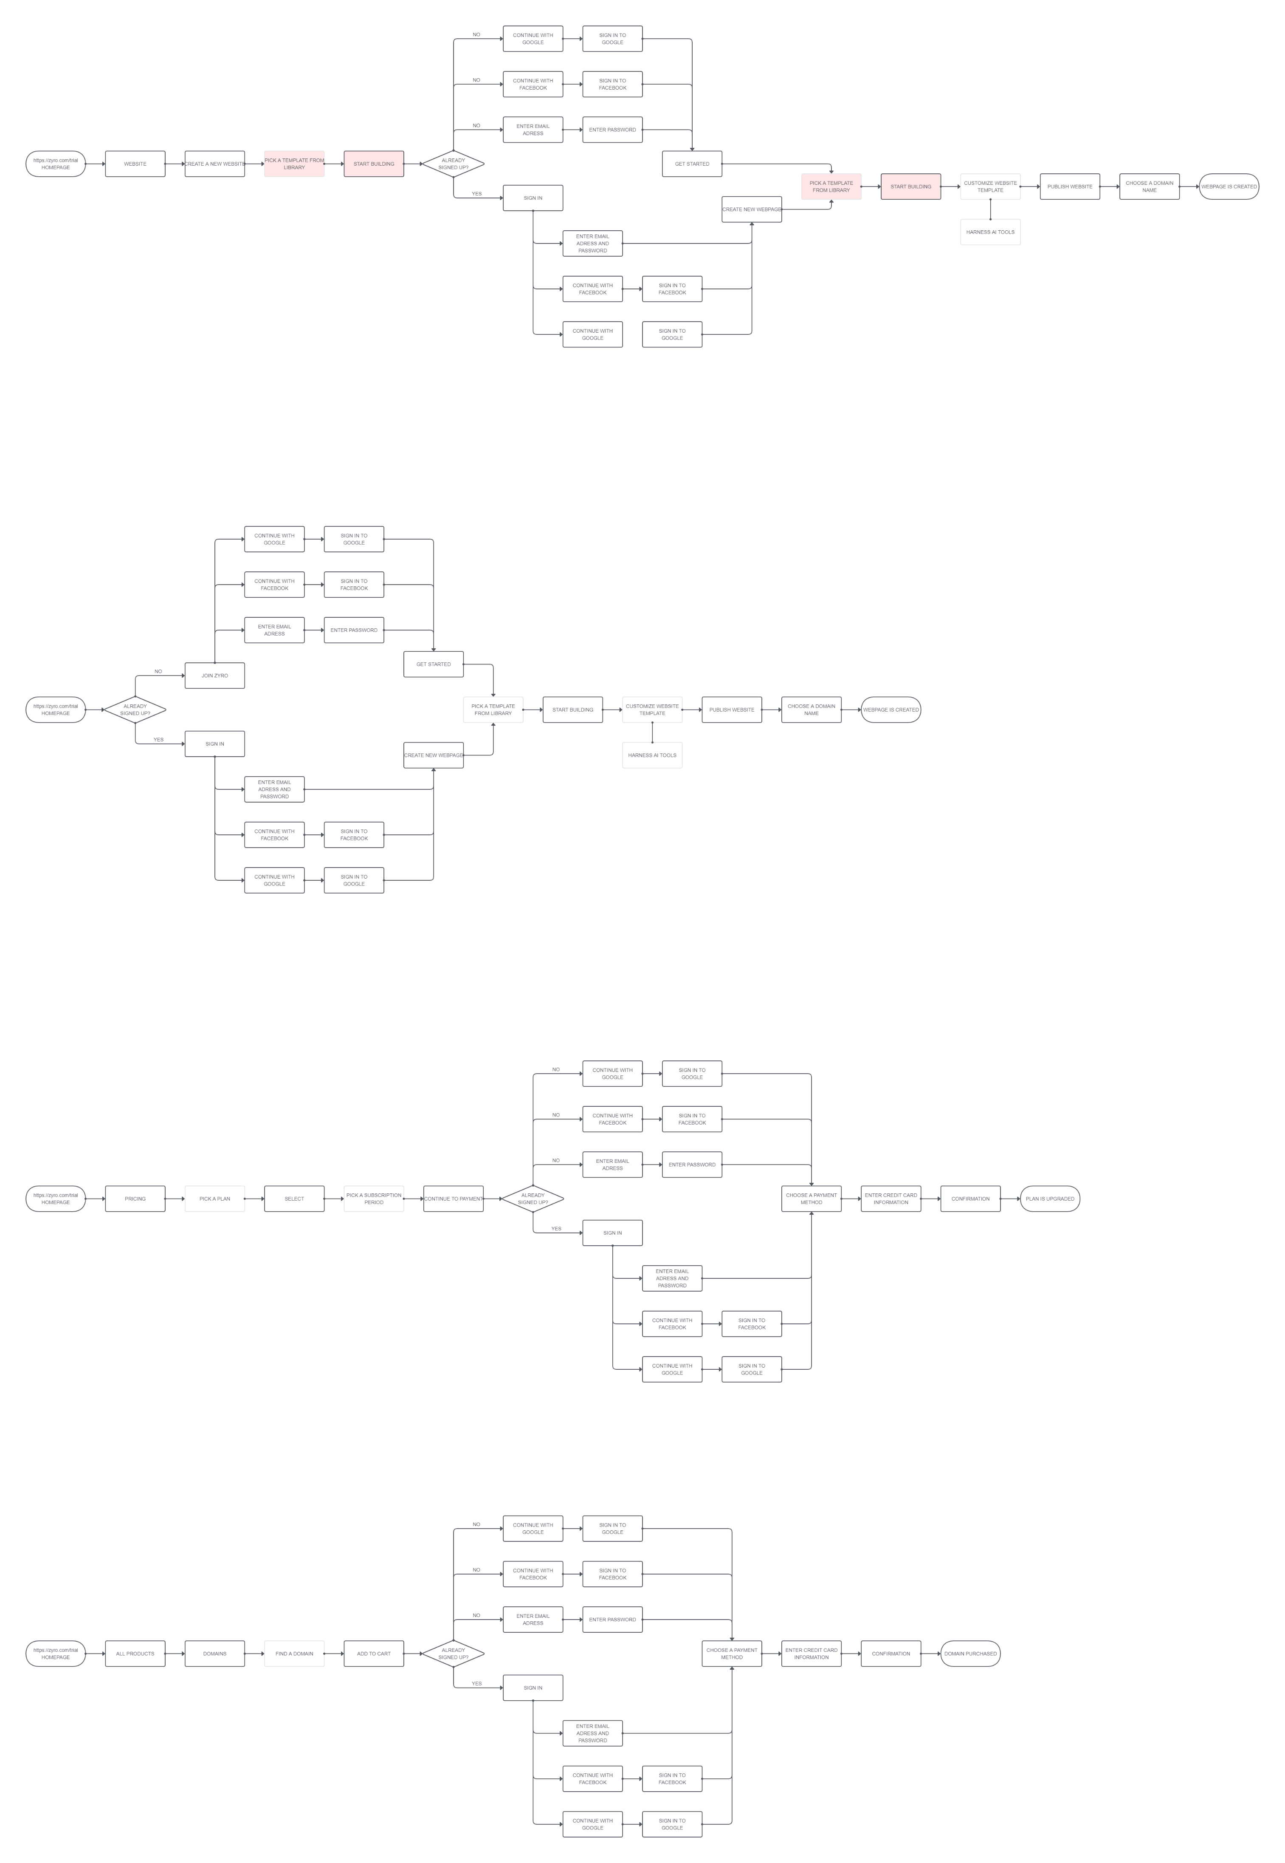

*Diagram 1*

2nd User flow:

**Upgrade plan**

1. User opens <https://zyro.com/trial> page in browser
2. User clicks “**Pricing**” button in navigation menu
3. User picks a plan and clicks “**Select**” button on the plan offer card accordingly
4. User picks a subscription period by checking radio button on offer container and clicks “**Continue to payment**” button below
5. User logs in to Zyro:
   1. New User clicks “**Join Zyro**” button in the upper right corner of the website -> registers with email address, or with Google or Facebook account
   2. Existing User clicks “**Sign in**” button in the upper right corner of the website -> enters email address and password, or continues with Google or Facebook account
6. User chooses a payment method by clicking on payment method logo
7. User enters credit card information or continues with log in to PayPal account
8. User payment confirmation
9. Plan is upgraded accordingly

“Upgrading plan” user flow is shown in the diagram (see “Diagram 2” below).

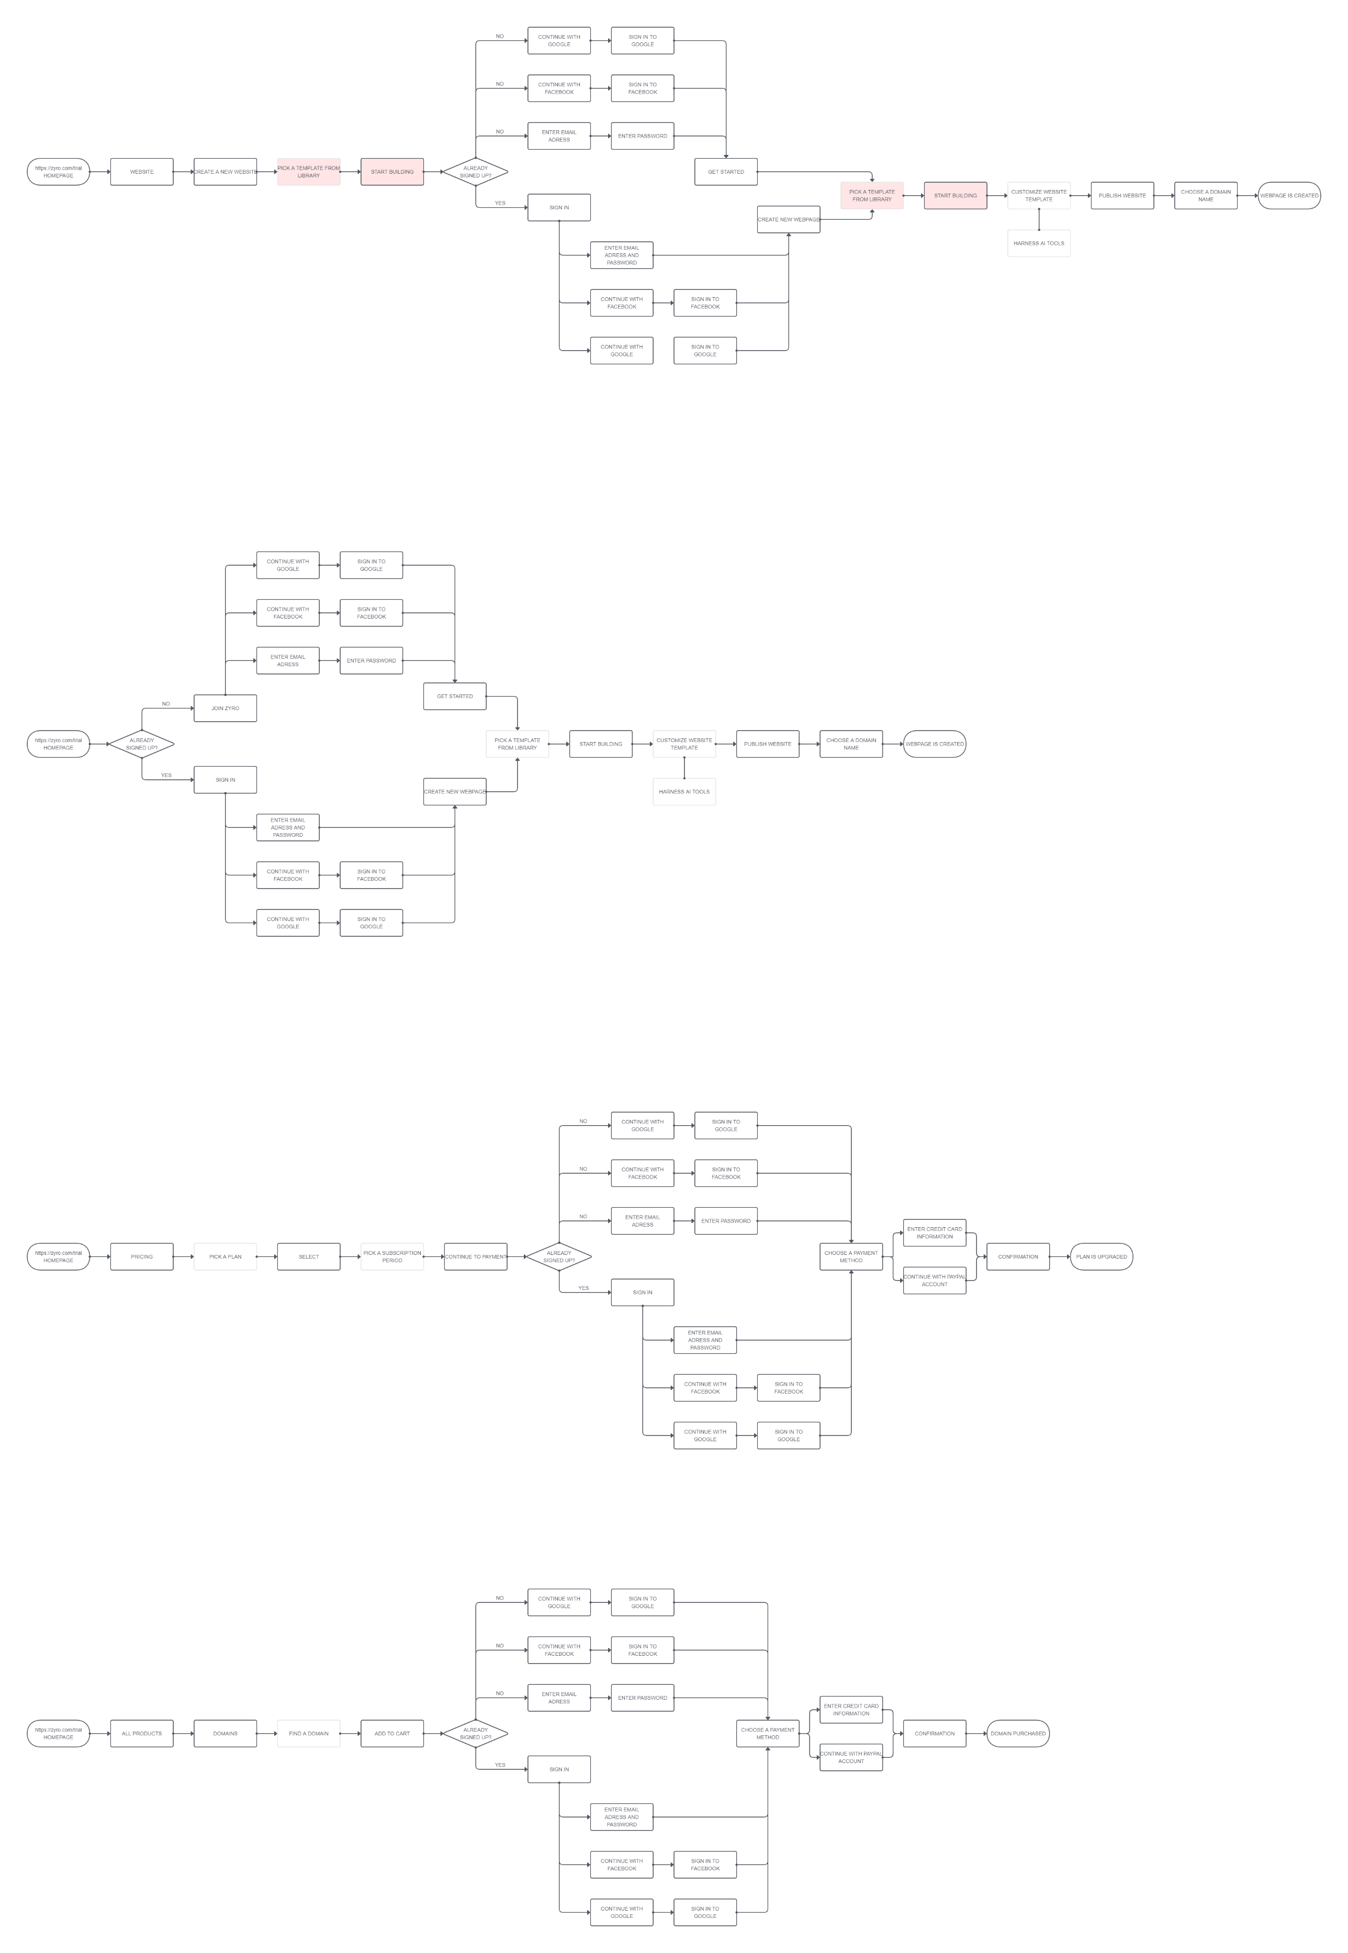

*Diagram 2*

3rd User flow:

**Purchase a domain name**

1. User opens <https://zyro.com/trial> page in browser
2. User clicks “**All products**” button in navigation menu
3. User clicks “**Domain**” button in “All products” dropdown menu
4. User finds a domain using search bar and picks it from all domain options below
5. User clicks “**Add to chart**” button located on the right side of the offer card
6. User logs in to Zyro:
   1. New User clicks “**Join Zyro**” button in the upper right corner of the website -> registers with email address, or with Google or Facebook account
   2. Existing User clicks “**Sign in**” button in the upper right corner of the website -> enters email address and password, or continues with Google or Facebook account
7. User chooses a payment method by clicking on payment method logo
8. User enters credit card information or continues with log in to PayPal account
9. User payment confirmation
10. Domain name is purchased

“Purchase a domain name” user flow is shown in the diagram (see “Diagram 3” below).

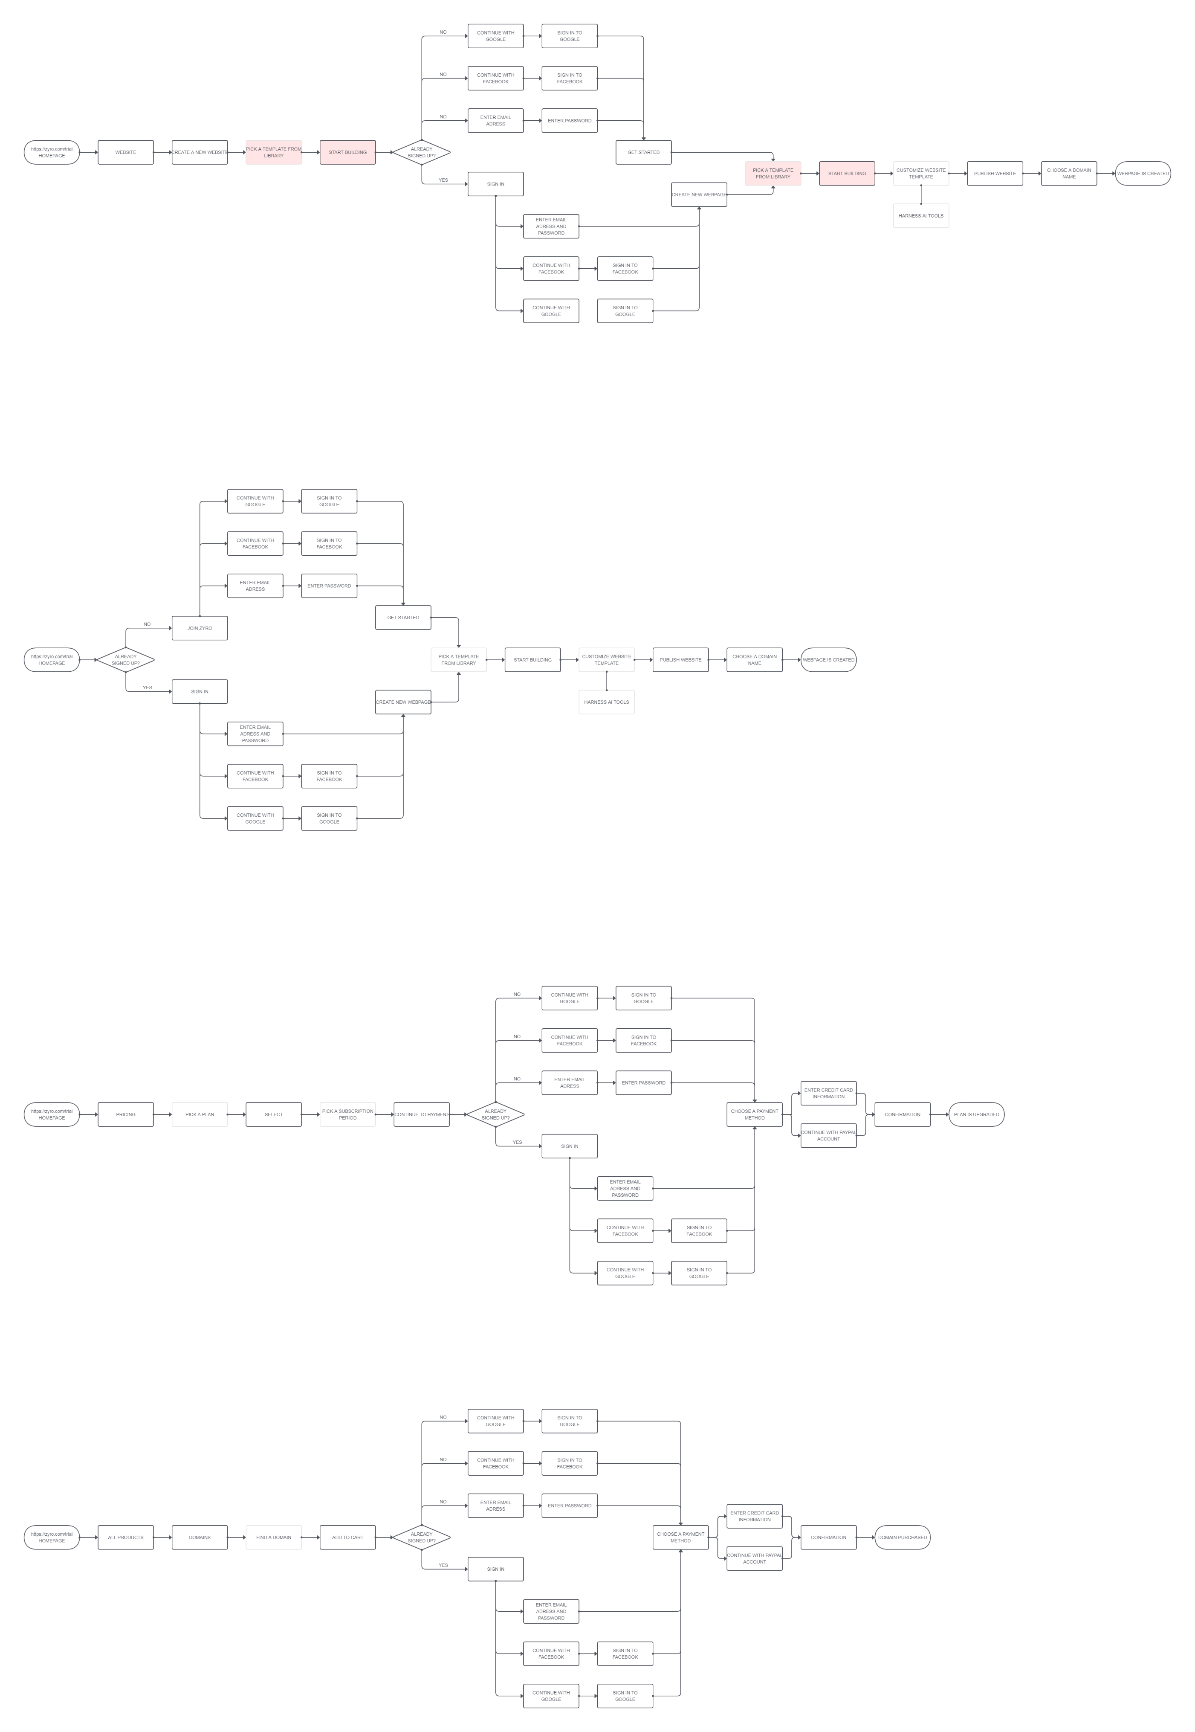

*Diagram 3*

Additional information:

-------------------------------------------------------------------------------

User can create a new webpage in several ways:

* Log in / Join Zyro -> Initiate new webpage creation (see 1st user flow above)
* Initiate new webpage creation -> Log in / Join Zyro (see below)

-------------------------------------------------------------------------------

“Initiate new webpage creation -> Log in” user flow:

1. User opens <https://zyro.com/trial> page in browser
2. User clicks “**Website**” button in navigation menu
3. User clicks “**Create a new webpage**” button
4. User picks a template from template library
5. User clicks “**Start building**” button
6. User logs in to Zyro:
   1. New User clicks “**Join Zyro**” button in the upper right corner of the website -> registers with email address, or with Google or Facebook account
   2. Existing User clicks “**Sign in**” button in the upper right corner of the website -> enters email address and password, or continues with Google or Facebook account
7. User initiates a new webpage creation:
   1. New User clicks “**Get started**” button in the center of the website
   2. Existing User clicks “**Create new webpage**” button in the upper right corner of the website
8. User picks a template from template library
9. User clicks “**Start building**” button which appears when user hovers mouse over the template
10. User customizes website template (adds images, text, and other website elements with Zyro’s intuitive website builder); User also can harness AI tools located in the right sidebar
11. User initiates the publication of a webpage by clicking “**Publish website**” button in the upper right corner of the website
12. User chooses a domain by entering a domain name in the label and clicks “**Continue**” button in the lower right corner of the modal
13. New webpage is created. User is informed that website is published and online
14. User clicks “**View your site**” button located on the right side of the domain to open created webpage in a new browser tab

This user flow has repetitive steps (see “Diagram 4” below).

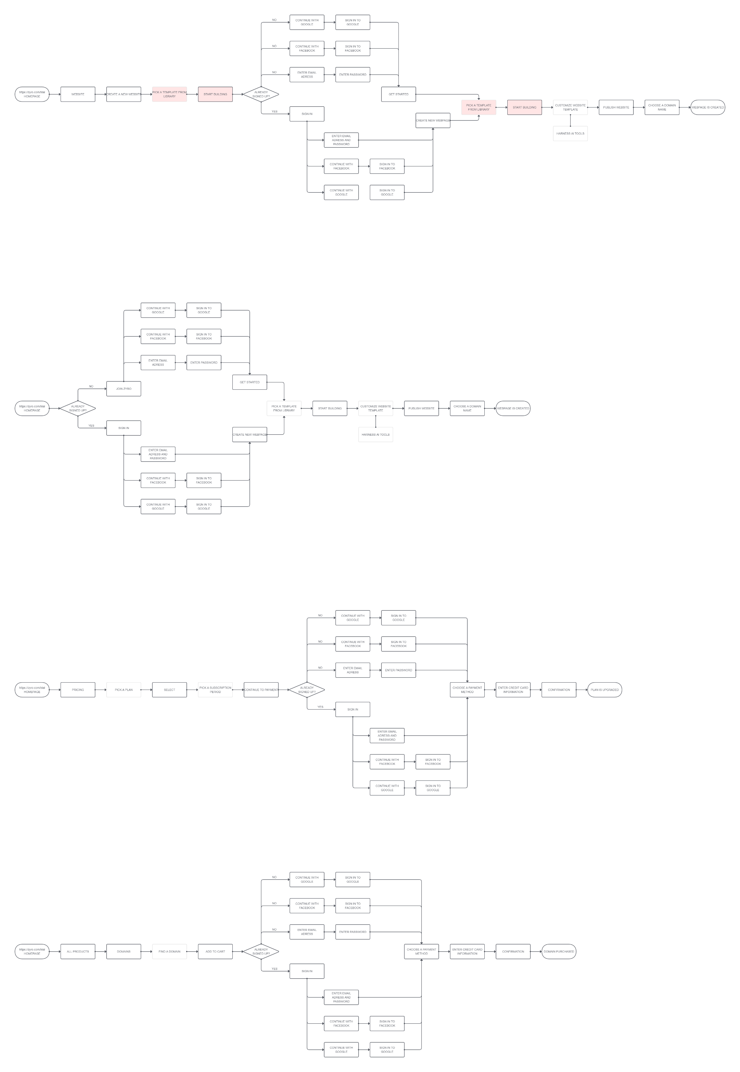

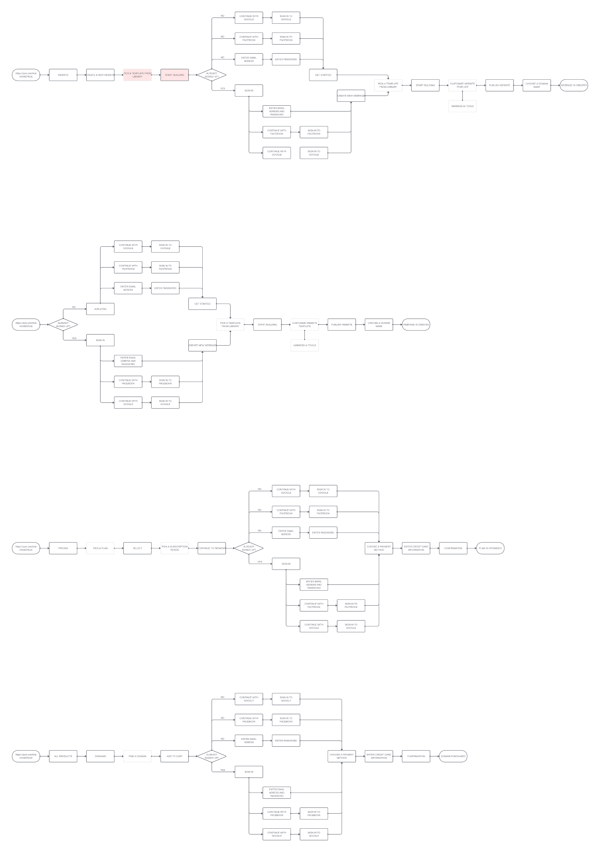 - repetitive steps

*Diagram 4*